

| **Revision History** | | |
| --- | --- | --- |
| **Revision** | **Date** | **Description** |
| 1.0 | 3/25/2024 | Initial Release |
| 1.1 | 4/30/2024 | Updated wording from fully to completely to fit with definitions in 3.2.2.5 ; Updated BOM |
| 1.1.1 | 5/03/2024 | corrected BOM link for Cosmic Shipping Container |
| 1.1.2 | 08/01/2024 | corrected BOM link for the paint |
| 1.1.3 | 08/27/2024 | corrected BOM price for the CSC |

# Contents

**Contents 2**

**1.0 Introduction 3**

What is IEEE SoutheastCon Hardware Competition? 3

**2.0 How to Use This Document 3**

**3.0 The Game 4**

3.1 Introduction 4

8.3.2 Game Description 4

3.2.1 Field Illustration 4

3.2.2 Gameplay Overview 5

3.3 Game Specific Definitions 6

3.4 Gameplay 7

3.4.1 Pre-Match 7

3.4.2 Match Play 8

3.4.3 Post-Match 9

3.5 Rules of Gameplay 9

3.5.1 Safety Rules 9

3.5.2 General Game Rules 10

3.5.3 Game-Specific Rules 11

3.5.4 Team Game Element Construction Rules 12

3.6 Scoring Summary 13

**Appendix A: Season Outline 14**

**Appendix B: Bill of Materials 15**

**Appendix C: Game Element CAD 16**

**Appendix D: Game Field CAD 17**

# 

# 1.0 Introduction

## What is IEEE SoutheastCon Hardware Competition?

IEEE SoutheastCon Hardware Competition is a student-centered program focused on giving college students a unique and exciting learning opportunity with robotics. Each year, teams take on a new game where they design, build, test, and program a fully *Autonomous* *Robot* to perform a series of tasks. The competition is held during the IEEE SoutheastCon that serves IEEE Region 3. To find out more about the conference visit <https://ieeesoutheastcon.org/>.

# 2.0 How to Use This Document

The intent of this manual is that the text means exactly, and only what it says. Please avoid interpreting the text based on assumptions about intent, implementation of past rules, or how a situation might be in “real life”. There are no hidden requirements or restrictions, If you have read everything, you know everything.

Keywords are defined either in Game Manual 1 (GM1) or in the 3.3 Game Specific Definitions section of this manual and will be formatted with the first letter capitalized and in italics. For example, the term *Robot* is a keyword with a definition in GM1.

| Notes from the Game Design Committee which are not rules but are contextual information useful for interpretation of rules are in purple boxes. |
| --- |

This document describes **Mining Mayhem**, the 2025 IEEE SoutheastCon Hardware Competition. We recommend viewing the game animation before reading this manual to gain a general understanding of the game. The animation is a brief summary of the game – It is not intended to provide all the necessary information to understand the official game rules fully. The animation can be accessed from [this link](https://youtu.be/E4D38Sqh8mc?si=SN6S_NB4uc2umx2x).

*Teams* must comply with all the rules and regulations provided by this document as well as Game Manual 1. Clarifications to the rules are issued in the Question and Answer section of the [Discord](https://discord.gg/n9QnBMQytg). Official Q&A responses take precedence over game manual text.

*Teams* should refer to Game Manual 1 for more information about the competition such as how rankings work, competition logistics, judged awards, and *Robot* construction rules.

# 3.0 The Game

## 3.1 Introduction

The year is 2047. After GRID successfully deflected asteroids from comet 2047-5-L1, it was discovered that they contained valuable materials, *Geodinium* and *Nebulite*. Your team’s rover is recruited to quickly collect these *Astral Materials* before the asteroids sail off into space, never to be seen again. Your robot touches down with T-3 minutes till the point of no return, so you have to collect as many astral materials as possible, put them into cosmic shipping containers, and bring them to the rendezvous pad communicated from the telemetry. There are also reports of a strange geographical feature like a cave… With the amazing materials your robot collects, the world will be able to build new technologies never seen before!

## 8.3.2 Game Description

### 3.2.1 Field Illustration

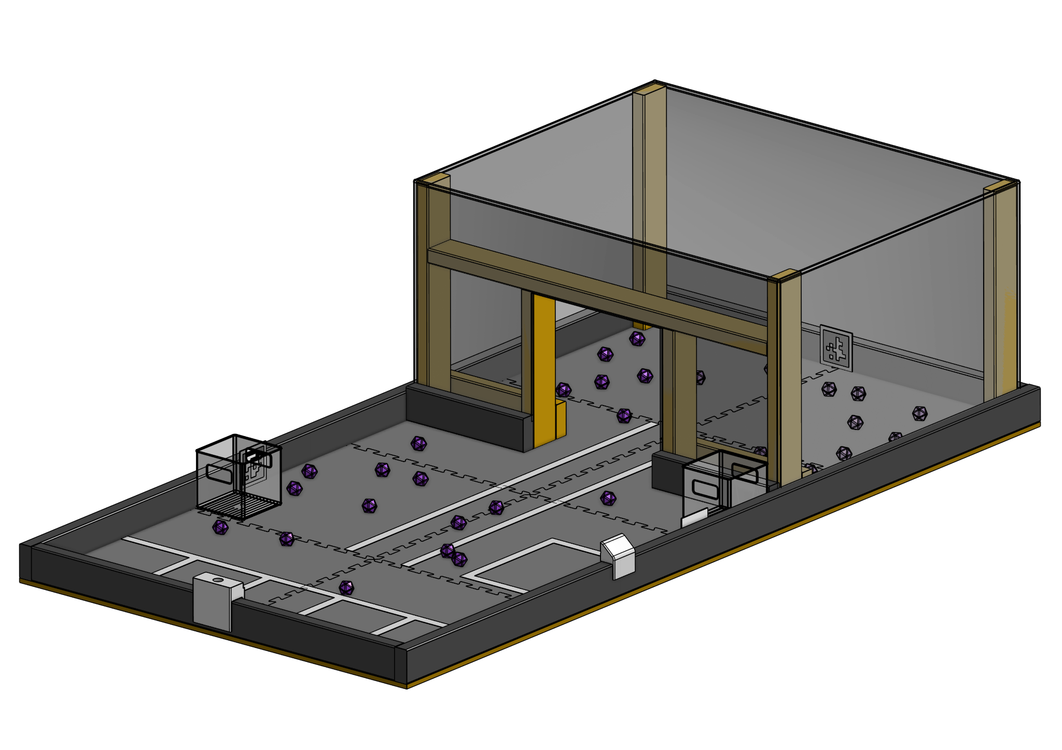

Figure 3.2.1-1

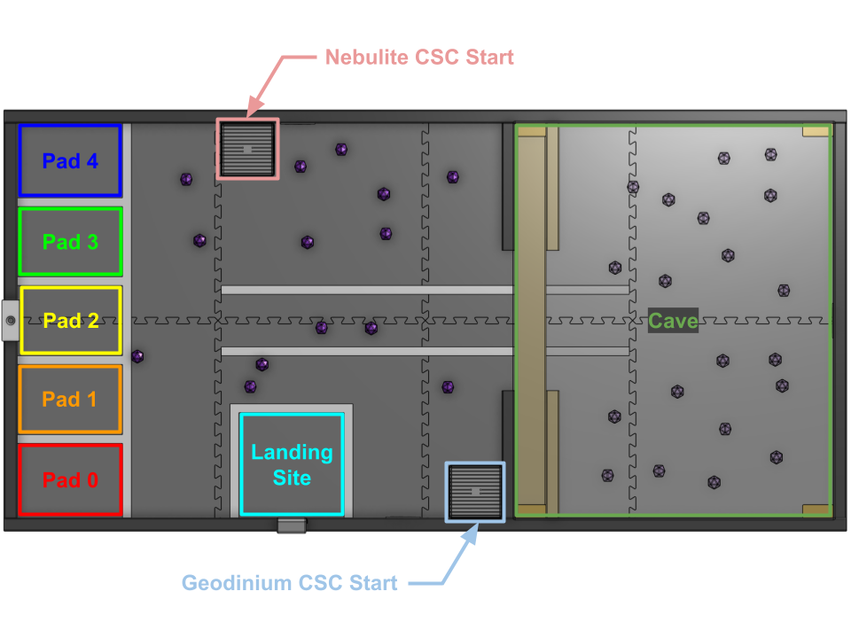

Figure 3.2.1-2

### 3.2.2 Gameplay Overview

Welcome to **Mining Mayhem**! *Matches* are played on a *Field* initially set up as pictured above in Figure 3.2.1-1. The object of the game is to earn as many points as possible by performing the achievements outlined below.

The *Match* starts either by a *Start LED* or via a start switch, from which point *Robots* operate *Autonomously* using only pre-programmed instructions and sensor inputs. The following *Robot* actions earn points during the *Match*.

1. *Robot* starting from the *Start LED*
2. *Robot* moving from *Landing Site*
3. A *Robot Unit* is *In* the *Cave* at any point during the *Match*
4. Identifying the *Rendezvous Pad* from the randomized *Telemetry*. *Teams* can earn points by
   1. Moving a *Cosmic Shipping Container* into any *Rendezvous Pad*
   2. Moving a *Cosmic Shipping Container* into the *Telemetry* identified *Rendezvous Pad*
5. Having an *Astral Material* *Completely* *Supported* by the *Robot* at the game end
6. Having an *Astral Material Completely In* the correct *Cosmic Shipping Container*
7. Having an *Astral Material Completely In* the incorrect *Cosmic Shipping Container*
8. Placing a *Beacon* in the *Beacon Mast*

## 3.3 Game Specific Definitions

**AprilTag** - A visual fiducial system, useful for a wide variety of tasks including augmented reality, robotics, and camera calibration[1]. Three (3) *AprilTags* are affixed to various locations within the *Field* to aid in *Robot* localization. *AprilTag* ID five (5) is affixed to the north wall. *AprilTag* ID six (6) is affixed to the south wall. *AprilTag* ID seven (7) is affixed to the east wall. One final *AprilTag* will be placed into the slot of the *Beacon Mast*. This *AprilTag* will have a randomized ID between zero (0) and four (4). The ID number of this *AprilTag* will indicate the preferred *Rendezvous Pad* and is also referred to as *Telemetry*.

**Area** - The space defined by the vertical projection of the inside edge of a region's boundary element. (tape, wall, etc) The boundary element is not part of the *Area*.

**Astral Materials** - *Astral Materials* are purple 3D printed icosahedrons and roughly 40 mm (1.6 inch) in diameter. *Astral Materials* come in two varieties: *Geodinium* and *Nebulite*.

**Beacon** - A *Team Game Element* that follows all the rules listed in section 3.5.4 and has passed *Inspection*. Can be placed into the *Beacon Mast* in order to score points.

**Beacon Mast** - A 3D printed *Game Element* placed in the middle of the west wall. The *Beacon Mast* contains a slot for the *Telemetry AprilTag* to be inserted. The *Beacon Mast* also contains a hole in the top, 1 inch (25.4 mm) in diameter, 1.25 inches (31.75 mm) deep, with a 10 degree draft angle for the *Team Beacon* to be placed.

**Cosmic Shipping Container (CSC)** - A clear plastic box roughly 6 inches x 6 inches x 6 inches in size. These *Game Elements* can be scored in *Rendezvous Pads* and are a scoring location for *Astral Materials*.

**Geodinium** - One of the two varieties of *Astral Materials*. A purple 40 mm (1.6 inches) diameter 3D printed icosahedron. In the core of each *Geodinium* are neodymium magnets which makes *Geodinium* slightly magnetic and heavier than *Nebulite*.

**In / Completely In** - An object that has crossed into the upwards vertical extension (i.e. normal to the *Field* floor) of a defined *Area’s* boundary is *In* the *Area*.

An object that is entirely within the upwards vertical extension of a defined *Area’s* boundary is *Completely In*. The boundary element (tape, wall, marking, etc) is not included in the *Area* unless otherwise specified.

**Inadvertent** - An unintended side effect of a *Robot* action. Unexpected *Robot* actions based on software commands are not considered to be *Inadvertent.*

**Inconsequential** - An outcome that does not influence scoring or gameplay.

**Landing Site -** The 12 inches x 12 inches *Area* indicated by tape where the robot will be placed at the start of a *Match*. The *Start LED* will be adjacent to this *Area* to indicate when a *Match* begins for *Autonomous* activation.

**Nebulite** - One of the two varieties of *Astral Materials*. A purple 40 mm (1.6 inches) diameter 3D printed icosahedron. *Nebulite* do not contain any added elements and are instead purely 3D printed plastic.

**Out / Completely Out** - An object that has at least some portion outside the upwards vertical extension of a defined *Area’s* boundary is *Out* (an object that is not *Completely In* is considered *Out).*

An object that has no portion within the upwards vertical extension of a defined *Area’s* boundary is *Completely Out*. The boundary element (tape, wall, marking, etc) is not included in the *Area* unless otherwise specified.

**Pre-Load** - A *Game Element* that a *Technician* positions during pre-*Match* setup so that it touches a *Robot* or is possessed by a *Robot*.

**Rendezvous Pad** - A scoring *Area* on the west side of the *Field* designated by tape. An array of five (5) *Rendezvous Pads* is marked by the tape ladder. Each rectangle created by the inside perimeter of the tape and the *Field* walls is a potential scoring location for *Cosmic Shipping Containers*. Each *Rendezvous Pad* has an associated number starting from the south-most *Area* having ID zero (0) and incrementing up to the north-most *Area* having ID four (4) as shown in Figure 3.2.1-2.

**Start LED** - The LED panel attached to the *Field* wall in the center of the south edge of the *Landing Site*. This LED is illuminated to indicate the start of the *Match*.

**Telemetry** - The *AprilTag* mounted in the *Beacon Mast* which indicates the *Rendezvous Pad* where *Cosmic Shipping Containers* are best placed.

**Support / Completely Supported** - An object is *Supported* by another object if the second object is bearing at least some of the weight of the first object. If the second object is bearing all the weight of the first object, it is *Completely Supported* by the second object.

## 3.4 Gameplay

### 3.4.1 Pre-Match

1. *Field* Personnel set up the *Field* as depicted in Figure 3.2.1-1
2. *Game Element* placement:
   1. *Astral Materials* in the *Cave*:
      1. Twelve (12) *Geodinium* randomly distributed.
      2. Eight (8) *Nebulite* randomly distributed.
   2. *Astral Materials* out of the *Cave*:
      1. Six (6) *Geodinium* randomly distributed.
      2. Eight (8) *Nebulite* randomly distributed.
   3. *Cosmic Shipping Containers*
      1. One (1) *Geodinium CSC* placed in the south-east corner of the out of cave *Area*. *CSC* handle holes are aligned west/east.
      2. One (1) *Nebulite CSC* placed along the north edge of the *Field*, 23.25 inches (590.55 mm) from the western wall. The western side of the *CSC* is aligned with the tile teeth edge. *CSC* handle holes are aligned west/east.
3. *Technician* set up their *Robots* on the *Field* with the following constraints
   1. *Robots* must be placed *Completely In* the *Landing Site*.
   2. The *Technician* may *Pre-Load* exactly one (1) *Beacon*. The *Pre-Loaded Beacon* does not have to be *Completely In* the *Landing Site.*
   3. The *Technician* declares to the ref that all settings are selected and the *Robot* is ready for match start.
4. Randomization
   1. The *Telemetry* signal is an *AprilTag* with an ID in the range zero (0) to four (4). The randomly selected *Telemetry* will be placed in the *Beacon Mast*.

### 3.4.2 Match Play

1. The match starts when a *Referee* turns on the *Start LED* and declares the *Match* started.
   1. If a *Team’s* *Robot* does not start with the *Start LED,* the *Technician* can press a Start Button/Switch that follows <R03>.
2. Points scored during a *Match*
   1. A *Robot Unit* becoming *Out* of the *Landing Site* earns five (5) points the first time it occurs.
   2. If a *Robot Unit* becomes *Out* of the *Landing Site* within 3 seconds of the *Start LED* being turned on, an additional five (5) points is earned.
   3. A *Robot Unit* becoming *In* the *Cave* earns fifteen (15) points the first time it occurs.
   4. If a *Team* has entered into the Promotional Design Competition, they earn five (5) points.
3. Points scored after a *Match*
   1. Cosmic Shipping Containers
      1. Each *Cosmic Shipping Container* *In* a non-*Telemetry* selected *Rendezvous Pad* earns fifteen (15) points.
      2. Each *Cosmic Shipping Container In* a *Telemetry* selected *Rendezvous Pad* earns thirty (30) points.
      3. If a *Cosmic Shipping Container* is *In* two or more *Rendezvous Pads,* it only scores as *In* the highest value pad.
   2. Astral Materials
      1. Each *Astral Material* *Completely Supported* by a *Robot Unit* earns one (1) point.
      2. Each *Astral Material* *Completely In* the wrong *Cosmic Shipping Container* earns two (2) points.
      3. Each *Nebulite* in the *Nebulite Cosmic Shipping Container* earns five (5) points.
      4. Each *Geodinium* in the *Geodinium* *Cosmic Shipping Container* earns six (6) points.
   3. If the *Team* *Beacon* has at least some portion of the object *In* the top facing hole of the *Beacon Mast* it earns forty (40) points.

### 3.4.3 Post-Match

1. After the three (3) minute timer ends or the *Technician* decides to stop the *Match* early, the *Technician* must stop all of their *Team’s Robot Units* without disturbing *Game Element* positions. Any gameplay that occurs after the timer ends or after the *Technician* begins to stop the *Robot* will not contribute to the *Team’s* score.

| It is highly suggested that teams include a mechanism to automatically stop their *Robot Units* 3 minutes after the *Robot* is started. Attempting to stop the *Robot* manually is allowed but can often lead to complications in scoring *Game Elements* that a *Robot* is interacting with at the end of the *Match*. Having a mechanism in place to automatically halt and idle all *Robot Units* is vastly preferred. |
| --- |

1. *Referees* will then finalize the score and signal to the *Technician* to retrieve their *Robot* *Units* and *Beacon*. *Field* personnel will then set up the playing *Field* for the next match
   1. Causing a delay of the match due to extremely complicated retrieval will result in a *Yellow Card*.

## 3.5 Rules of Gameplay

### 3.5.1 Safety Rules

**<S01> Robot Action Envelope -** *Robots* must remain on the *Field* and are not allowed to interact with anything outside the *Field*. *Robots* are allowed to reach outside the *Field* up to 12 inches (304.8 mm) outside of the *Field* perimeter. If a *Robot* noticeably reaches further, or contacts any objects outside of the *Field*,the *Team* will be issued a *Yellow Card*. If a *Referee* determines the rule infringement was intentional and consequential, the *Team* can be issued a *Red Card*.

**<S02> Game Element Action Envelope -** Similar to <S01>, *Game Elements* must remain on the *Field* and are not allowed to interact with anything outside the *Field*. *Game Elements* are allowed to reach outside the *Field* up to 12 inches (304.8 mm) outside of the *Field* perimeter. If a *Game Element* noticeably reaches further, or contacts any objects outside of the *Field*,the *Team* will be issued a *Yellow Card*. If a *Referee* determines the rule infringement was intentional and consequential, the *Team* can be issued a *Red Card*.

| *Robots* and *Game Elements* are intended to compete on the *Field*, not with the surrounding environment. The intent of the reaching rules is to allow *Robots* some freedom in extending beyond the *Field* to accommodate sizable mechanisms. However, space around the *Field* is finite so a limit must be set. *Robots* and *Game Elements* are allowed to interact with all parts of the *Field* and *Field* perimeter however, the *Field* may be placed on the floor, and touching the floor outside the *Field* perimeter (even inside the 12 inches (304.8 mm) allowance) would constitute interaction with outside environments and would receive a penalty. Also, consider that the 12 inches (304.8 mm) allowance will likely only be policed by eye. We strongly recommend that *Teams* stay far from the limit to avoid unnecessary penalties. |
| --- |

**<S03> Unsafe *Robot* or *Field Damage*** - If at any time *Robot* operation is deemed unsafe or has damaged the *Field*, by the determination of the *Referees*, the *Match* will end early, all *Robot Units* must be stopped as quickly as possible, and the *Team* will receive a *Yellow Card*. Damage that requires significant repair and/or delays subsequent *Match* play is likely to escalate to a *Red Card*.

### 3.5.2 General Game Rules

**<G00> Practice Fields** - Practice *Fields* will be provided by hardware competition organizers. *Teams* are not permitted to bring their own practice fields to the *Pit Area* due to spacing considerations. Time on the provided practice *Fields* will be coordinated by event organizers.

**<G01> Robot Manipulation of Scoring Elements** - *Robots* are permitted to interact with the *Game Elements* in any way that is not damaging to the *Game Elements*. There is no limit to how many *Game Elements* a *Robot* can carry at a time. There are no restrictions as to how the *Robot* grasps or manipulates the *Game Elements*.

**<G02> Inadvertent and Inconsequential** - Accidental, non-consequential damage to the *Field* can be ruled *Inadvertent and Inconsequential* as a discretionary call by the *Referee*. If an action is deemed *Inadvertent* and *Inconsequential* there will not be a penalty assigned.

**<G03> Playing Field Tolerances** - Competition provided *Field* and *Game Elements* will start each *Match* with positional tolerances that may vary by 土 1 inch (25.4 mm). *Teams* should design their *Robots* accordingly.

| *Field* and *Game Elements* are expected to be manufactured, assembled, and setup using a high standard for dimensional and location accuracy. The intent of the generous +/- 1 inch is to accommodate any unintentional size and location variations that might occur due to the warping tendencies of wood. |
| --- |

**<G04> Starting Volume** - The starting *Robot* configuration should not exceed the starting volume of a 12 inches x 12 inches x 12 inches cube designated by the *Landing Site* region on the *Field*. After the *Match* begins, the *Robot* is permitted to expand beyond these dimensions. The only exception is that the *Pre-Loaded* *Team Beacon* may exceed the starting volume.

**<G05> Post-Match Removal** - The *Technician* is responsible for stopping the *Robot* at the end of the *Match.* The *Robot* should be able to be stopped via the emergency stop button for safe retrieval.

**<G06> Starting Early / Starting Late** - An early start via premature activation of the start switch or faulty sensing of the *Start LED* will result in a *Yellow Card*. There is no penalty for a late start, nor will additional *Match* time be compensated for a late start.

**<G07> End-Of-Period Robot Actions** - Any actions taken by the *Robot* that would result in scoring points after the *Match* time has expired will not be counted. However, any actions that would result in *Field* or *Game Element* damage will still be penalized with a *Yellow Card*.

**<G08> Robot Control** - *Robots* are to be *Autonomous*. No external commands or signals of any kind may be used to manipulate the *Robot’s* actions during the *Match*.

**<G09> Technician Contact with Field** - During *Pre-Match* set-up the *Technician* is allowed to set and position the *Robot* in any way within the 12 inches starting cube outlined by the *Landing Site*. The *Technician* is allowed to *Pre-Load* one *Beacon* during *Pre-Match*. This *Beacon* is permitted to exceed the dimensions of the 12 inches starting cube. The Technician is not permitted to touch or manipulate any other aspect of the *Field* or *Game Elements*. Any intentional violation of this rule will result in a *Red Card*.

**<G10> Egregious Behavior** - *Teams* are intended to be respectful of each other at all times. They should be mindful of the space they occupy within the hardware room and keep all of their belongings within their *Team’s* designated spaces. Any behavior that is deemed inappropriate can result in disqualification from the competition.

### 3.5.3 Game-Specific Rules

**<GS01> Interacting with Robot/Field After Randomization** - Interactions with the *Field* after *Randomization* of the *Game Elements* is forbidden. If this occurs, the *Robot* cannot score points for any tasks affected by *Randomization* (*Telemetry* tasks).

**<GS02> Cave Filming** - In order for audiences to see what is happening in the cave, there will be an IR emitting infrared camera inside the cave.

### 3.5.4 Team Game Element Construction Rules

**<TE01> Inspection** - Each *Team Game Element* must pass *Inspection* before it is allowed to be used in a *Match*.

**<TE02> Material Constraints** - The *Team Game Element* is subject to the *Robot* Mechanical Parts and Materials Rules in GM1 section 5.2.1.

**<TE03> Size Constraints** -

1. The maximum size of the *Team Game Element* is 6 inches (101.6 mm) x 6 inches (101.6 mm) x 8 inches (203.2 mm)
2. The minimum size of the *Team Game Element* is 3 inches (76.2 mm) x 3 inches (76.2 mm) x 6 inches (101.6 mm).
3. The *Team Game Element* must be large enough to not fit *Completely In* a rectangular prism of the minimum size, but must be small enough to fit *Completely In* a rectangular prism of the maximum size.

**<TE04> Labeling** - The *Team Game Element* must be labeled or constructed in such a way that it is obvious what *Team* it belongs to.

| *Teams* are encouraged to be creative in construction and decoration of *Team Beacons*. Labeling requirements will be leniently enforced and mostly exist so that *Team Beacons* can be easily differentiated, identified, and returned to *Teams*. |
| --- |

## 

## 3.6 Scoring Summary

| **Scoring Achievement** | **Score** | **Reference** |
| --- | --- | --- |
| Out of Landing Pad | 5 | 3.4.2.2.a |
| Out of Landing Pad within 3 seconds of Start LED | 5 | 3.4.2.2.b |
| Robot becomes In the cave | 15 | 3.4.2.2.c |
| Entering Promotional Design Competition | 5 | 3.4.2.2.d |
| A CSC in non-telemetry rendezvous pad | 15 | 3.4.2.3.a.i |
| A CSC in a telemetry rendezvous pad | 30 | 3.4.2.3.a.ii |
| Astral Material Completely Supported by a Robot | 1 per Astral Material | 3.4.2.3.b.i |
| Astral Material Completely In wrong CSC | 2 per Astral Material | 3.4.2.3.b.ii |
| Nebulite in Nebulite CSC | 5 per Nebulite | 3.4.2.3.b.iii |
| Geodinium in Geodinium CSC | 6 per Geodinium | 3.4.2.3.b.iv |
| Team Beacon in Beacon Mast | 40 | 3.4.2.3.c |

# 

# Appendix A: Season Outline

| **Event** | **Date / Frequency** | **Description** |
| --- | --- | --- |
| Field Assembly Guide Release | April 30th, 2024 | This is when we will release the field assembly guide, a supplemental document aimed at helping create your field as close as possible to the real field. |
| Calls with GDC | Once a month, starting in April | These calls are a great way to meet other people in the community and get some unofficial clarifications on rules. They will be about an hour long. Each month we will send out a form with a couple of options and the highest-voted one will be the date/time. |
| SoutheastCon! 🎉 | March 27-30, 2025 | This is the conference the competition is held at! |

# 

# Appendix B: Bill of Materials

| **Item** | **Price** | **Quantity** | **Total Price** | **Item Link** | |
| --- | --- | --- | --- | --- | --- |
| Field Floor | $30.28 | 1 | $30.28 | <https://www.homedepot.com/p/23-32-in-x-4-ft-x-8-ft-RTD-Sheathing-Syp-129323/303564747> | |
| 2”x4”x8’ | $2.65 | 6 | $15.90 | <https://www.homedepot.com/p/2-in-x-4-in-x-8-ft-Prime-Stud-058449/312528776> | |
| Wood screws | $9.98 | 1 | $9.98 | <https://www.homedepot.com/p/Grip-Rite-9-x-3-in-Star-Drive-Bugle-Head-Construction-Screw-1-lb-Box-3GCS1/204959258> | |
| Black Paint | $9.98 | 1 | $9.98 | <https://www.homedepot.com/p/Glidden-Premium-1-gal-Base-3-Flat-Interior-Paint-GLN9013N-01/206755823> |  |
| Staple Gun | $19.98 | 1 | $19.98 | <https://www.homedepot.com/p/Arrow-T50-Heavy-Duty-Staple-Gun-T50/100021099> | |
| Field Tiles | $9.99 | 2 sets | $19.98 | <https://www.harborfreight.com/4-piece-anti-fatigue-foam-mat-set-94635.html> | |
| Mine Fabric (6 yards) | $26.99 | 1 | $26.99 | <https://www.amazon.com/Blackout-Drapery-Percent-Waterproof-Sunshade/dp/B06XRV935T> | |
| Gaffers Tape | $19.99 | 1 | $19.99 | <https://www.amazon.com/Professional-Premium-Grade-Gaffer-Tape/dp/B00ZRYP38I?th=1> | |
| White PLA | $18.99 | 1 | $18.99 | [https://www.amazon.com/OVERTURE-Filament-Consumables-Dimensional-Accuracy/dp/B07PGZNM34](https://www.amazon.com/OVERTURE-Filament-Consumables-Dimensional-Accuracy/dp/B07PGZNM34?crid=29Y9Y8BEXVCX4&th=1) | |
| Purple PLA | $23.99 | 1 | $23.99 | <https://www.amazon.com/OVERTURE-Filament-Consumables-Dimensional-Accuracy/dp/B07VFQS5J3> | |
| Magnets | $16.99 | 3 | $50.97 | <https://www.amazon.com/dp/B0CP1N6432> | |
| IR Camera | $34.99 | 1 | $34.99 | <https://www.amazon.com/Arducam-Computer-Automatic-Switching-All-Day/dp/B0829HZ3Q7/> | |
| Cosmic Shipping Container | $16.99 | 2 | $33.98 | <https://www.amazon.com/Royal-Imports-Flower-Acrylic-Vases/dp/B083Y6NF9X/> | |
| Double Sided Tape | $15.73 | 1 | $15.73 | [https://www.amazon.com/HitLights-Heavy-Double-Sided-Mounting/dp/B00PKI7IBG](https://www.amazon.com/HitLights-Heavy-Double-Sided-Mounting/dp/B00PKI7IBG?crid=2GOA6S574VQAN&dib=eyJ2IjoiMSJ9.mUbqxYfX5RyrWbEqPa3Ks5lL3vki7IHc7c6m8xzIBR1NHJ6iG8MTnkjguIb6vIWDCd5sTzepe6yxdJUwGqYQlxQi6OmVaA1av9UlT3kLQZI2k7eLz8dKUu2hS-zAJTicW0mQpHUL5ZG-a_hq7gLqkAywAsWaJwXcmEq70WxafV2kPTmwwR7F-QLcM-0YXpKfLat5DbK0nnem57bhlVk6kkStp3oFsAG-C-gtk41qeUI.QoiPUv8sT0PQCb9kI5Gw36WlWN4Td5IWambDlWGvK9w&dib_tag=se&keywords=double+sided+vhb&qid=1710653346&sprefix=double+sided+vhb,aps,84&sr=8-4&th=1) | |
| Start LED | $2.50 | 1 | $2.50 | <https://www.adafruit.com/product/1622#technical-details> | |
| Total |  |  | $334.23 |  | |

# Appendix C: Game Element CAD

[Astral Materials CAD](https://cad.onshape.com/documents/75aed577e7c49832ad23e07b/w/971e38a3dabe4892a039b2e1/e/fca5f5b9ddc248e1bac8039f)

[Cosmic Shipping Container CAD](https://cad.onshape.com/documents/46b510ee201a3a59f9d6de9f/w/f223bf5ec00a1511e4aa1591/e/244c803dd518662dd1d8e8f7)

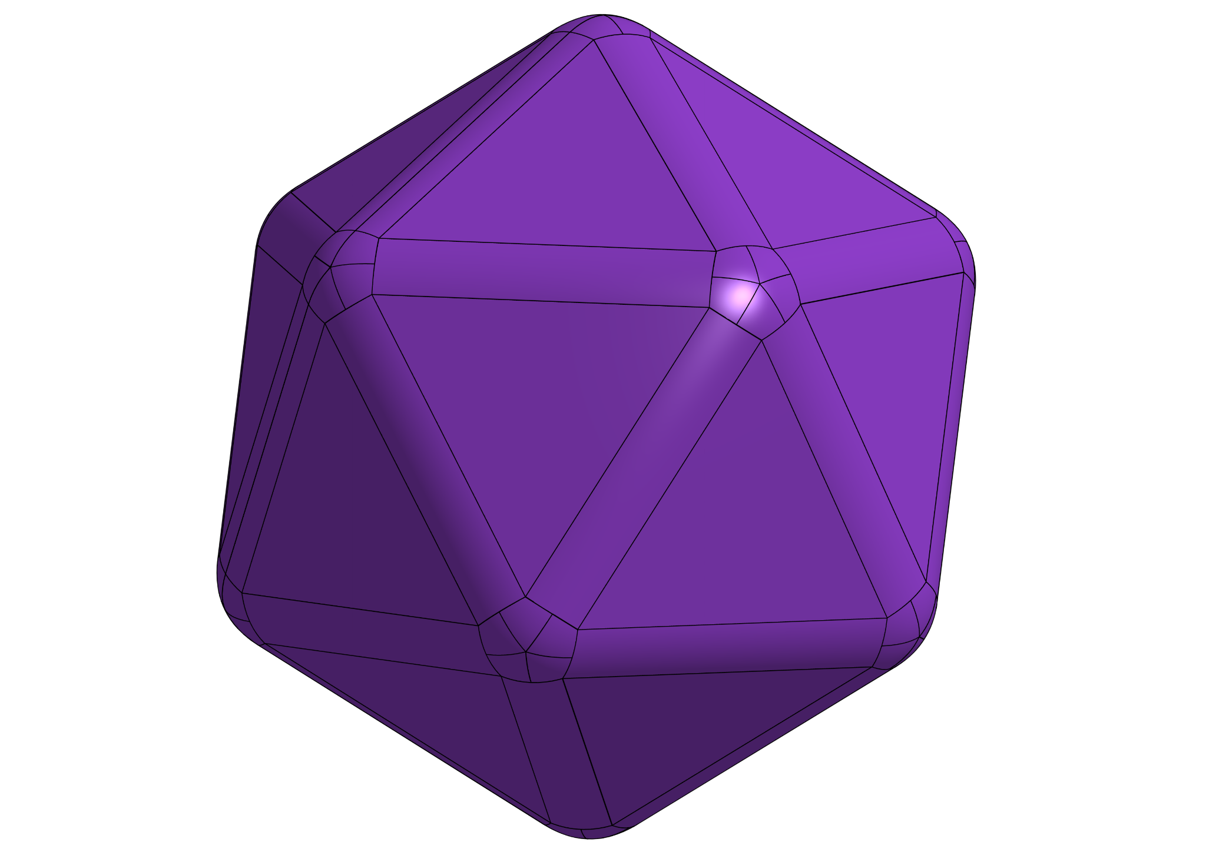

Figure C-1: Astral Material

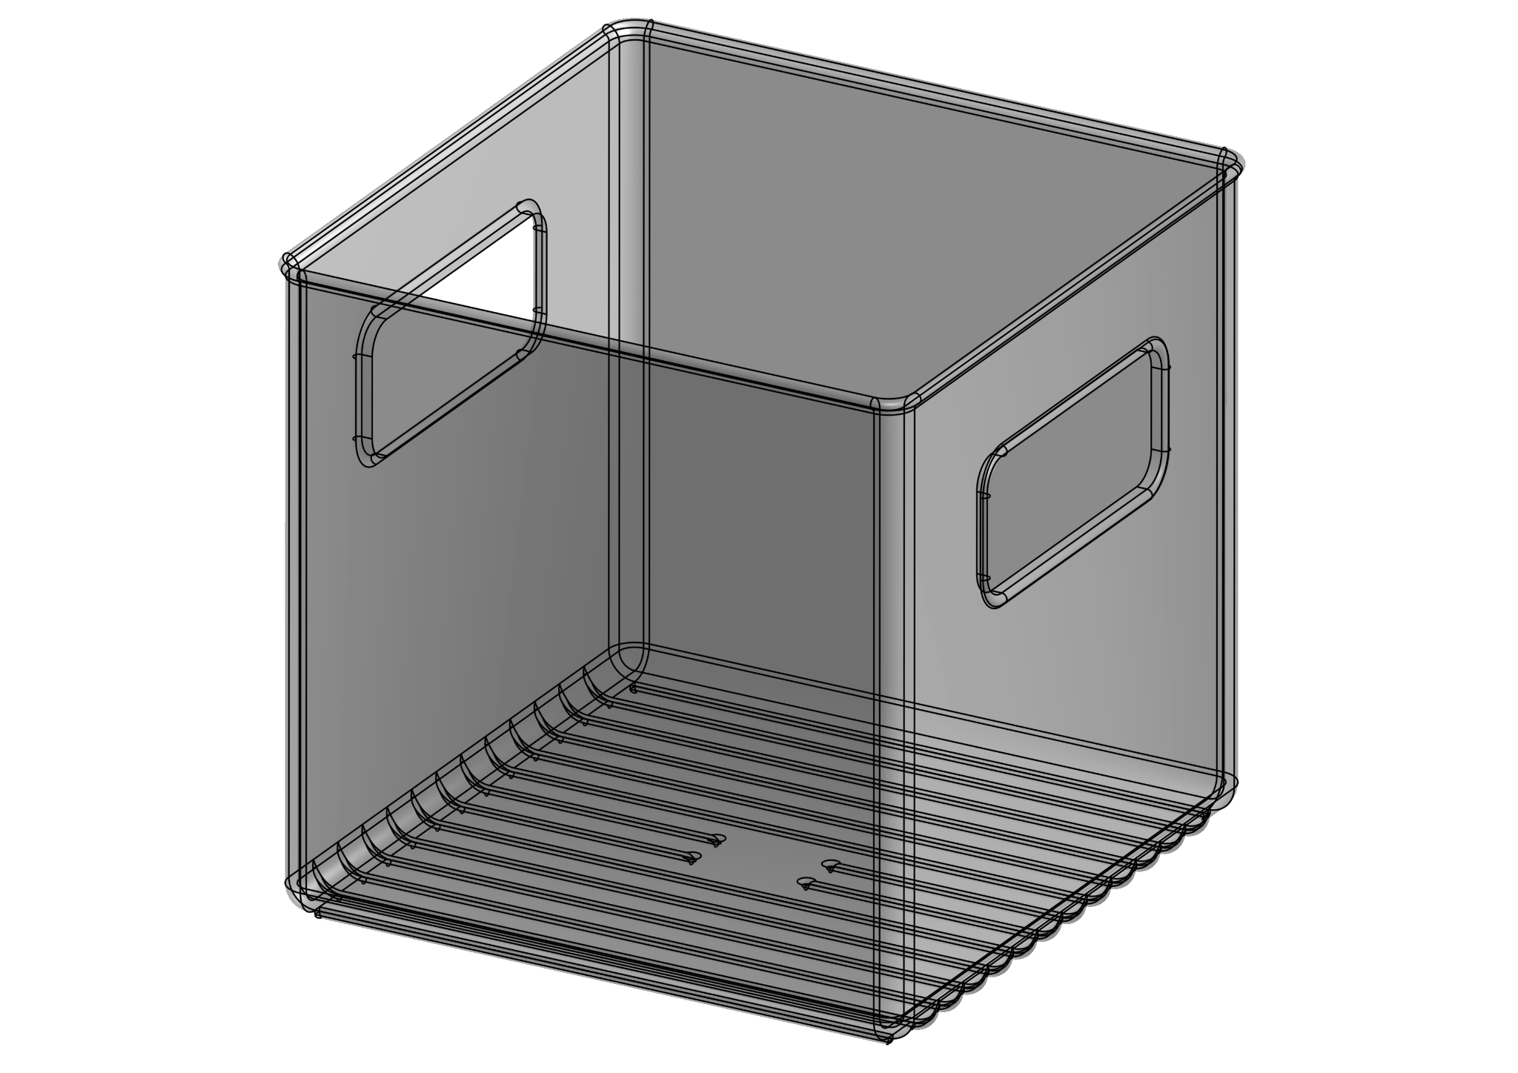

Figure C-2: Cosmic Shipping Container

# Appendix D: Game Field CAD

[Game Field CAD](https://cad.onshape.com/documents/46b510ee201a3a59f9d6de9f/w/f223bf5ec00a1511e4aa1591/e/390a47491ac7fc7e37334dd4?renderMode=0&uiState=65fdfb47d2ba1a22b827765c) - [Game Field Mechanical Drawings](https://cad.onshape.com/documents/46b510ee201a3a59f9d6de9f/w/f223bf5ec00a1511e4aa1591/e/5897e7e68208d0889daa2710) (click Sheets middle-left to see all 3)

[Start LED CAD](https://cad.onshape.com/documents/46b510ee201a3a59f9d6de9f/w/f223bf5ec00a1511e4aa1591/e/b05e8ebf77fbe45bf3a36d89)

[Beacon Mast CAD](https://cad.onshape.com/documents/46b510ee201a3a59f9d6de9f/w/f223bf5ec00a1511e4aa1591/e/47dac40b468c9397727dce97)

[AprilTag CAD](https://cad.onshape.com/documents/3439c0ef3aabd99db9666557/w/ff91868ece0e7c5b627a089e/e/9a614066910682209ce324a4)



Figure D-1: Game Field

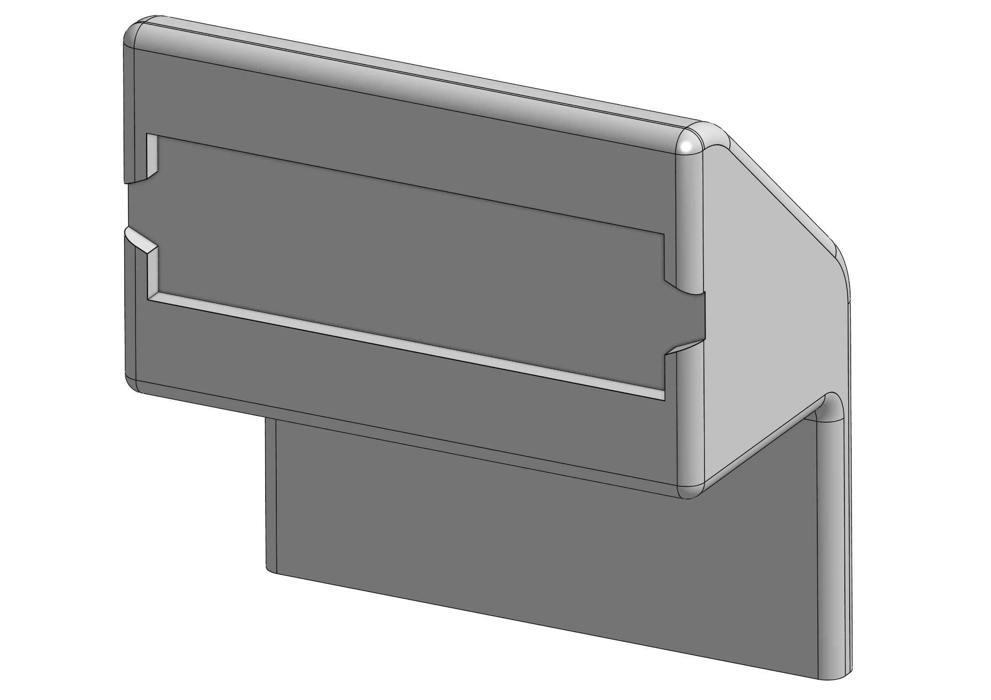

Figure D-2: Start LED

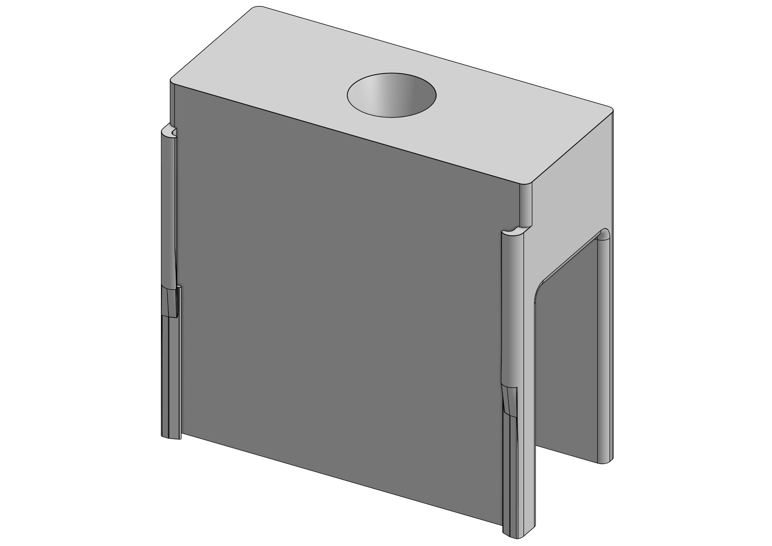

Figure D-3: Beacon Mast

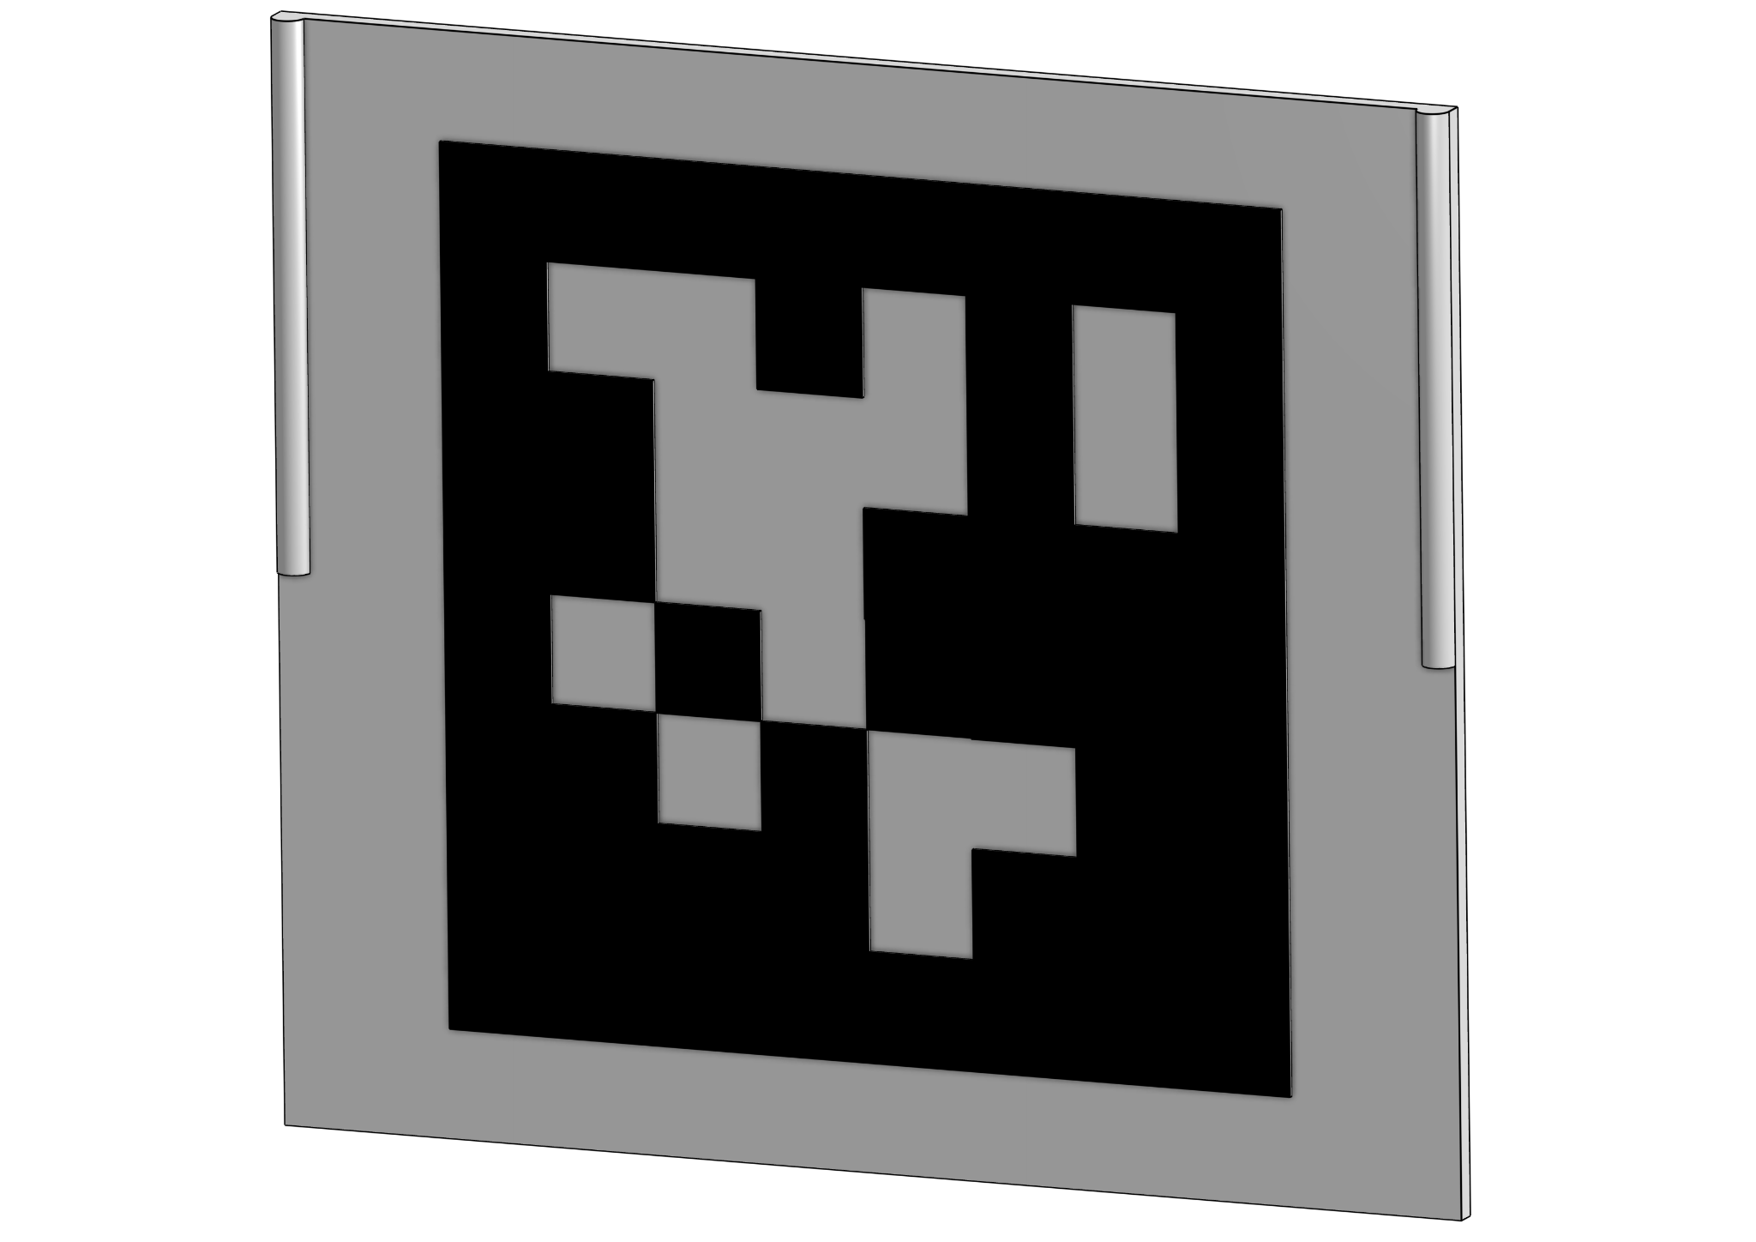

Figure D-4: AprilTag ID 0

1. See <https://april.eecs.umich.edu/software/apriltag> accessed on 3/6/24